INS3121
December 15, 2017

SOIL MECHANICS
Group 4: Assoc . Prof. Dr. Pelin Özener
Group 5: Asst. Prof. Dr. Nejat N. Çetinkaya
MIDTERM II
Q.1/25p | Q.2/25p | Q.3/25p | Q.4/25p | TOTAL
Name and Surname:
Number:
Group:

a) Explain briefly normally-consolidated clay and over-consolidated clay. Which one has more convenient properties for foundation? Explain with reasons. (5p).
- What is consolidation coefficient? Explain briefly how it can be determined (5p).
- What are the parameters that affect shear strength of sandy soils? (5p)
- Which laboratory tests are used to determine the shear strength parameters of soils? Briefly describe the unconfined compression test (5p).
- What are the assumptions of “Terzaghi’s Consolidation Theory”, explain briefly (5p).

- A soil profile given below is composed of sand and clay layers. A sample was recovered from in the middle of the clay layer and performed laboratory oedometer (consolidation) test in order to determine its void ratio-pressure relationship. The results of the void ratio (e) –pressure (σ_{v}') of a consolidation test conducted on a soil specimen are given in the following table. According to this;
- Plot void ratio (e) – logarithmic pressure (log σ_{v}') curve of the clay soil using the following graph and determine the pre-consolidation pressure (σ_{p}'), compression index (C_{c}) and swelling (recompression) index (C_{s}) (18p).
- Check if clay layer in the field is normally consolidated or over consolidated clay. Write down the reasons that lead to occurrence of overconsolidated situation. (7p).
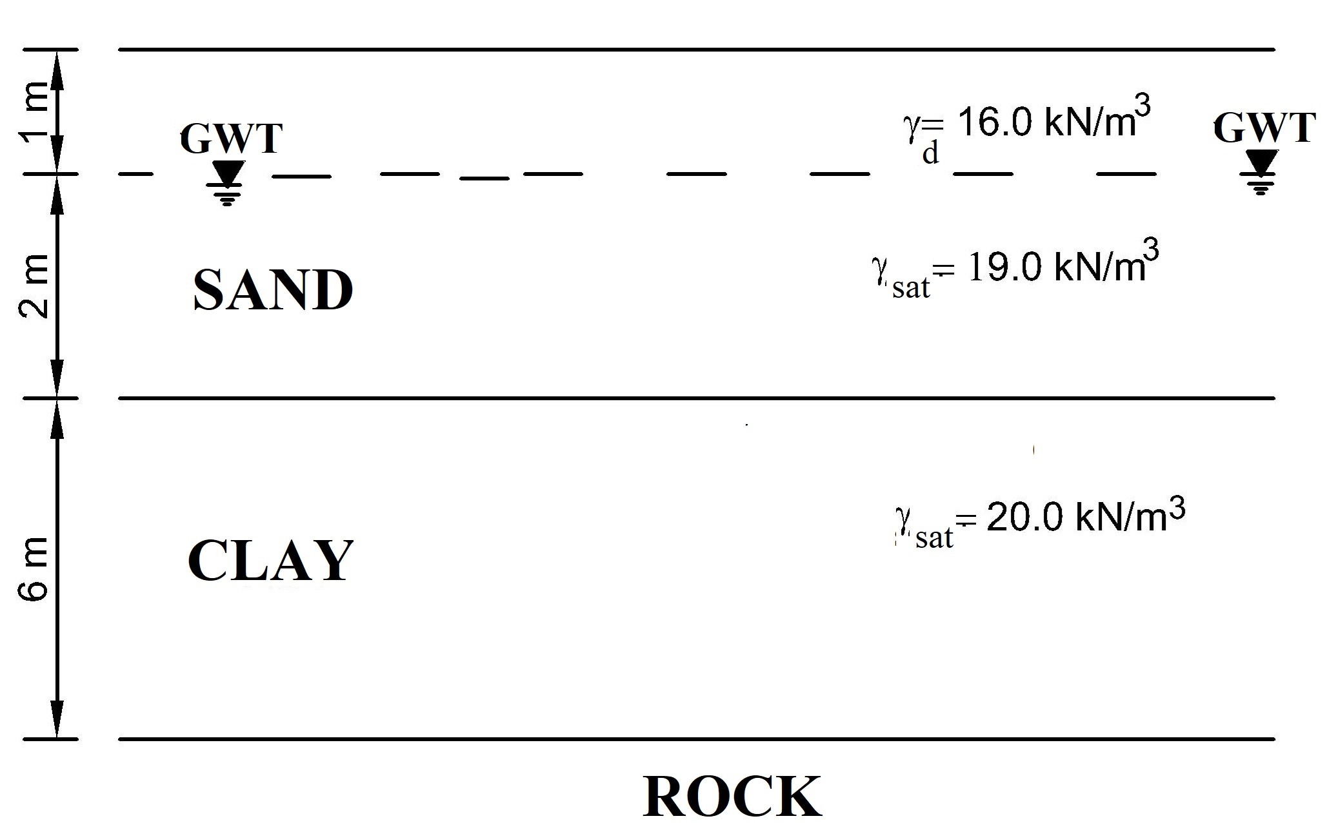

σ'_{v} (kPa) | e (void ratio)
25 | 0.93
100 | 0.89
200 | 0.83
400 | 0.76
800 | 0.69
400 | 0.7
200 | 0.71

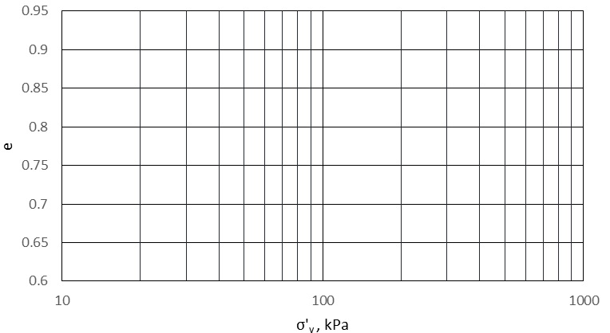

- A silo with a diameter of 24 m will be constructed on the sand soil layer shown below. The transmitted load from silo to ground surface (including foundation load) is equal to 100000 kN. According to this;
- Calculate the stress increase in the middle of the clay layer for center of silo by Boussinesq Method (7p).
- A laboratory oedometer tests were carried out on clay sample taken from the field. In accordance with the test results it was determined that clay layer in the field is normally consolidated and its compression index (C_{c}) is equal to 0.32. If initial void ratio (e₀) is equal to 0.8 and saturated unit weight of clay is 19.0 kN/m³, calculate the final consolidation settlement caused by silo construction by using stress increase result obtained from part a (If you couldn’t find the stress increase from part a, assume the stress increase in the middle of the clay layer is equal to silo base pressure) (7p).
- The consolidation coefficient (c_{v}) of clay layer was determined as 2.56x10⁻⁴cm²/sec from the result of oedometer test. Calculate the required time for 90% of consolidation (7p).
- Calculate the effective vertical stress in the middle of the clay layer at the end of the final consolidation settlement. (4p).
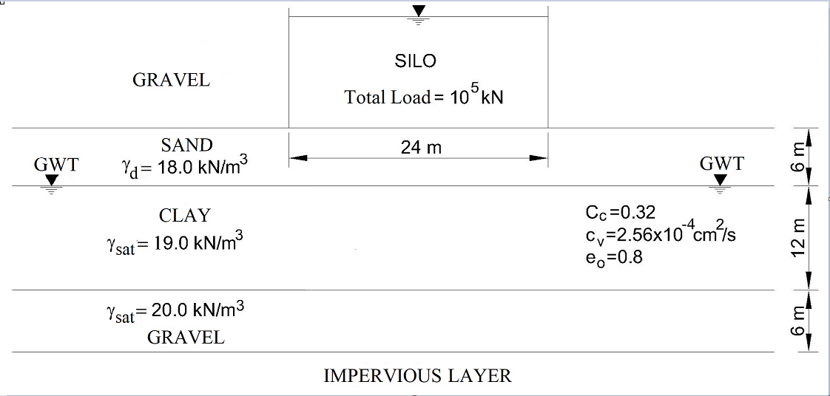
U (%) | 10 | 20 | 30 | 40 | 50 | 60 | 70 | 80 | 90
T_{v} | 0.008 | 0.031 | 0.071 | 0.126 | 0.197 | 0.287 | 0.408 | 0.567 | 0.848

- A shear box test was carried out on a sand sample. The results of normal stress and maximum shear stress obtained from shear box test are shown below;
  - Draw Mohr-Coulomb failure envelope (10p).
  - Determine the shear strength parameters of sand soil (10p).
  - Calculate the angle of failure plane (α_{f}) of sand soil (5p).
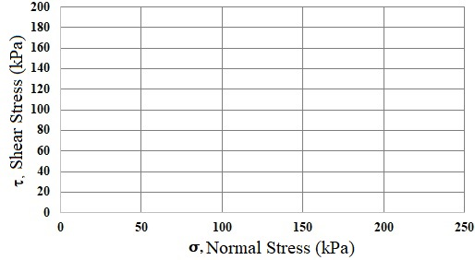
Test Number | Normal Stress (kPa) | Max. Shear Stress (kPa)
1 | 50 | 45
2 | 100 | 82.5
3 | 150 | 122.5
4 | 200 | 172.5

Time is 80 minutes. Good Luck…

